PAPER TITLE
Ivanov I.I.^{1*}, PhD (Eng.), Associate Professor; Petrenko P.P.², DSc (Eng.), Professor
¹ National University “Odessa Maritime Academy”, Ukraine
² Second organization, Country
* Corresponding author: ivanov@example.com
Keywords: navigation; integrated navigation system; ECDIS; safety of navigation.
Introduction. Text of the paper. It is recommended to divide the text into sections: introduction, problem statement, conclusions. Maritime transport carries a large share of world trade, and its efficiency and safety depend directly on the competence of seafarers and the technical equipment of ships. The development of digital technologies, automated control systems and electronic navigation opens up new opportunities, but at the same time places new demands on the safety of navigation and on the professional training of crews [1], [2]. Research in the field of navigation, shipping and maritime technologies therefore remains relevant.
Authors and affiliations. If the authors work in different organizations, each surname is followed by a superscript number that refers to the affiliation list. The corresponding author is marked with an asterisk (*), and his or her e-mail address is given below the affiliations.
Citation rules. Papers in English follow the IEEE citation style. References are cited in the text by a number in square brackets placed inside the sentence punctuation, e.g. [1]. Sources are numbered in the order of first citation, and the same number is reused each time the source is cited. A specific page is given after the number: [3, p. 45]; a page range as [3, pp. 45–47]. Several sources are separated by commas, [3], [4], and a range is given with an en dash: [1]–[3]. Direct quotations are enclosed in quotation marks and must include the page number. Every source in the reference list must be cited in the text.
Technical requirements. The paper length is 3–6 pages including figures, tables and references; page numbers are not added. The UDC (Universal Decimal Classification) code is optional: if it is unknown, it will be assigned by the editors. Give 3–5 keywords separated by semicolons. Formulas are typed in the Word equation editor. Figures are inserted at their final size with legible labels. Abbreviations are spelled out at first use, e.g. Electronic Chart Display and Information System (ECDIS). Footnotes are not allowed.
Problem statement. One of the key tasks of navigation is timely detection of the risk of collision and the choice of an effective avoidance manoeuvre [3], [4]. As an example, Fig. 1 shows how the distance between two ships changes for different course alterations of the give-way vessel.
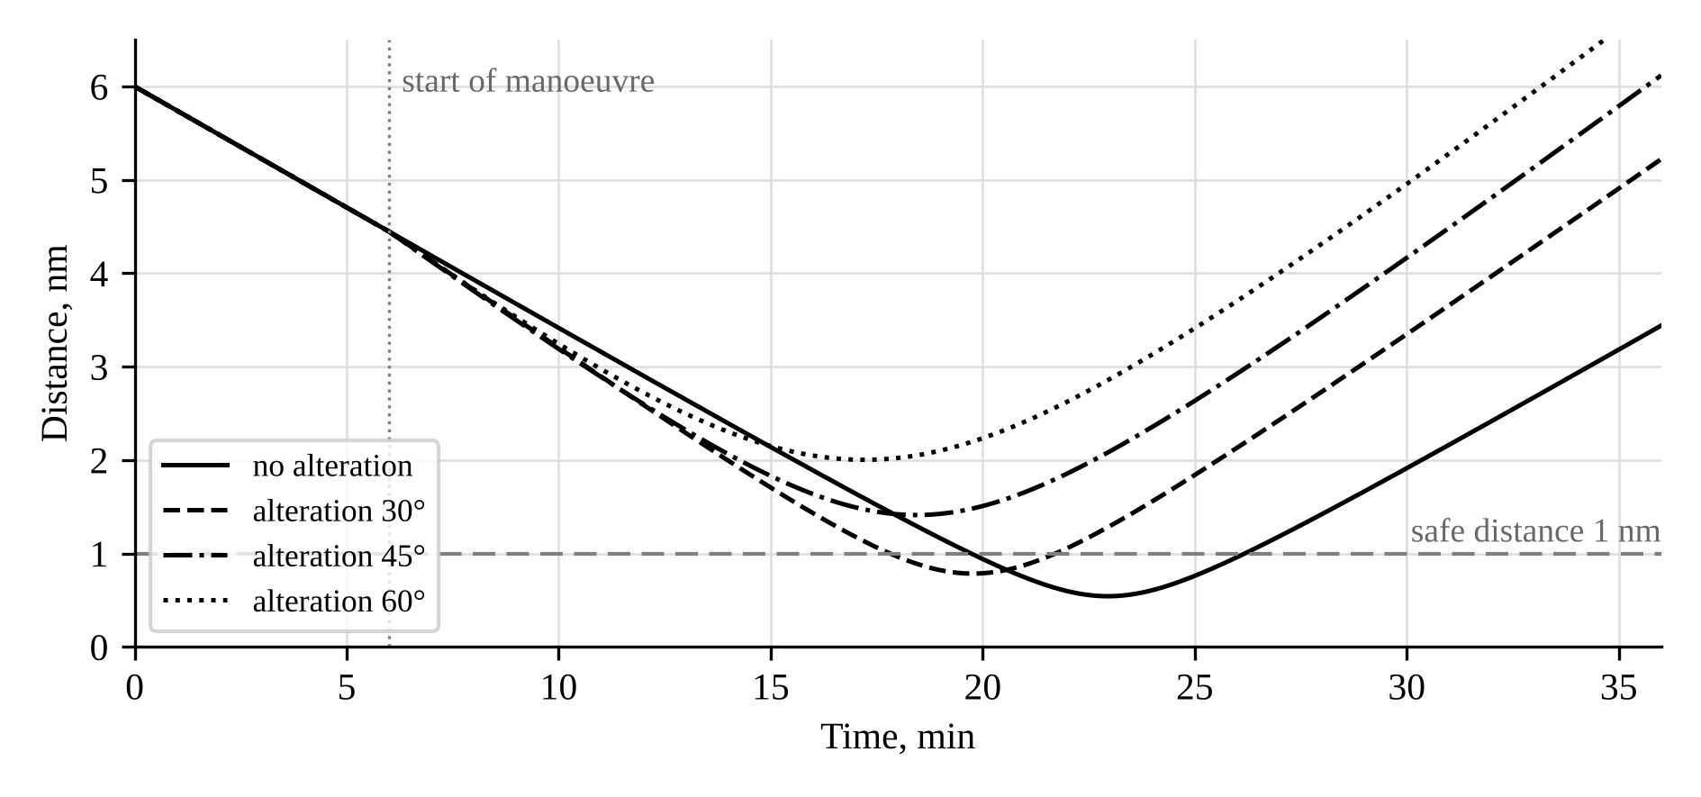
Figure 1. Change in the distance between ships for different course alterations
Text text text text text text text text text text text text text text text text. Requirements for ships flying the flag of Ukraine are additionally established by national legislation [5].
$E=mc^{2}$ (1)
Table 1. Table title
Parameter 1 | Parameter 2 | Parameter 3
Value 1 | Value 2 | Value 3

Conclusions. The research results are summarized and the main conclusions are formulated here.
REFERENCES
- A. N. Cockcroft and J. N. F. Lameijer, A Guide to the Collision Avoidance Rules, 7th ed. Oxford, U.K.: Butterworth-Heinemann, 2012.
- International Maritime Organization, SOLAS: Consolidated Edition 2020. London, U.K.: IMO, 2020.
- N. Bowditch, The American Practical Navigator: An Epitome of Navigation, Pub. No. 9. Springfield, VA, USA: National Geospatial-Intelligence Agency, 2019.
- International Maritime Organization, STCW Including 2010 Manila Amendments, 3rd ed. London, U.K.: IMO, 2011.
- Verkhovna Rada of Ukraine, Merchant Shipping Code of Ukraine, No. 176/95-VR, May 23, 1995. [Online]. Available: https://zakon.rada.gov.ua/laws/show/176/95-вр (Accessed: Oct. 13, 2026).

